Gaeun Kim
MTH 4040
Vectors and Vector Operations
GeoGebra is a simple but powerful tool which can be used by students to understand math concepts, to help solve problems and to check solutions. GeoGebra can be used for statistics, for probability, for geometry, for trigonometry, for algebra and for functions.
A vector is a directed line segment, whose length is the magnitude of the vector and with an arrow indicating the direction.
Creating vector using GeoGebra
We are going to insert two vectors:
u = <3,2>
v = <-2,4>
In order to insert these two vectors, type “vector((3,2))” in the “input” section at the bottom of screen and hit “enter.” Do the same process with vector v [type “vector((-2,4))”]
There is another way to insert vectors by going over the line tab and click “vector.” Start at point of (0,0) and then drag it to the point (3,2) and (-2,4).
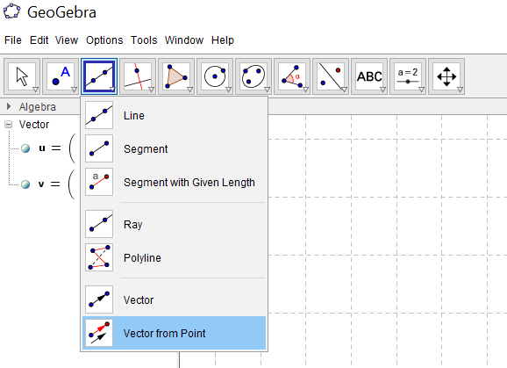

Once you enter these two vectors, your graph should look like this.
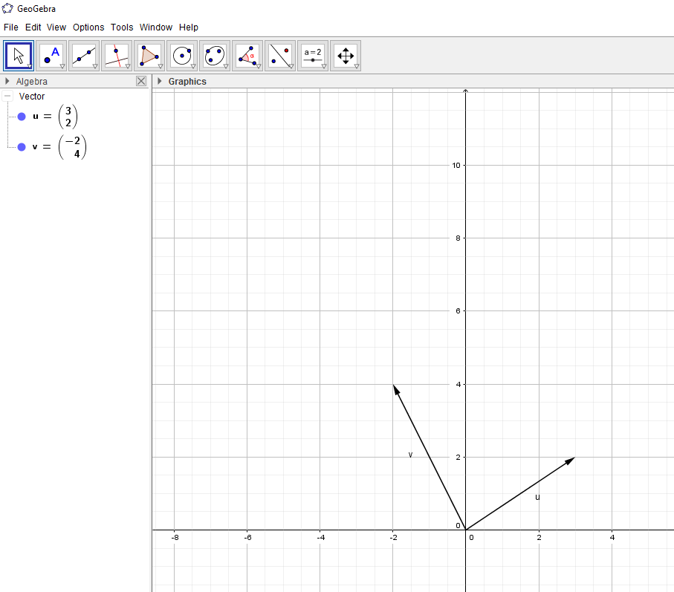
If you don’t see the label of each vector, right click on the vectors and click “show label.”
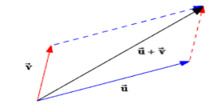
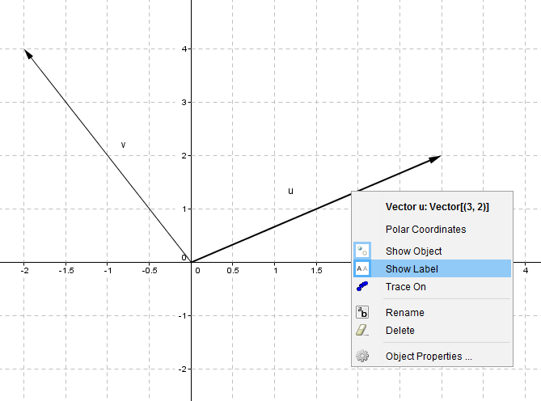

Vector Addition
Before we move on to addition, insert a point on each head of the vector by using “point tool.” Then, click “vector from point” under the line tool. Click point A and click the vector (3,2). Then, you will get the same vector (3,2) but placed at the head of vector (-2,4). It is a parallel translation. We are using parallelogram method in order to find the sum of these two vectors.
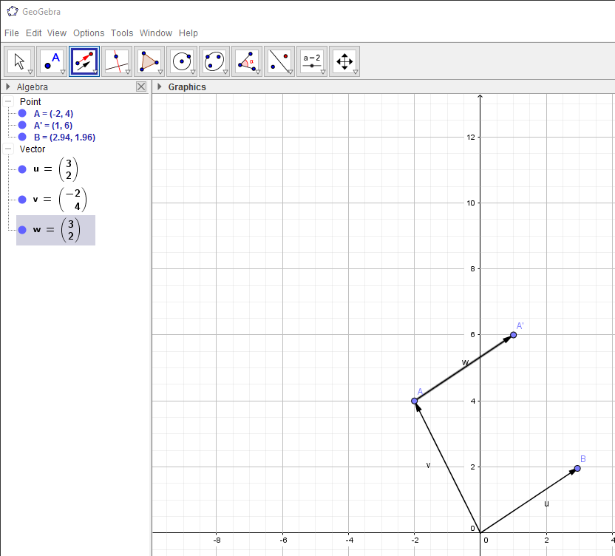

Now, type “m=u+v” in the “input” section then your graph will look like this and the coordinates of vector m will be __________ which is the sum of vector u and v.
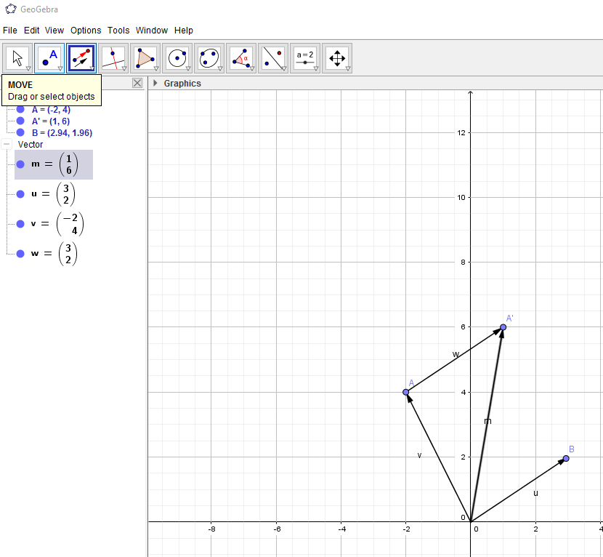
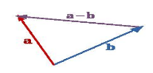
Vectors Subtraction
Type w=v-u into “input” box. Once you hit “enter,” your graph should look like this.
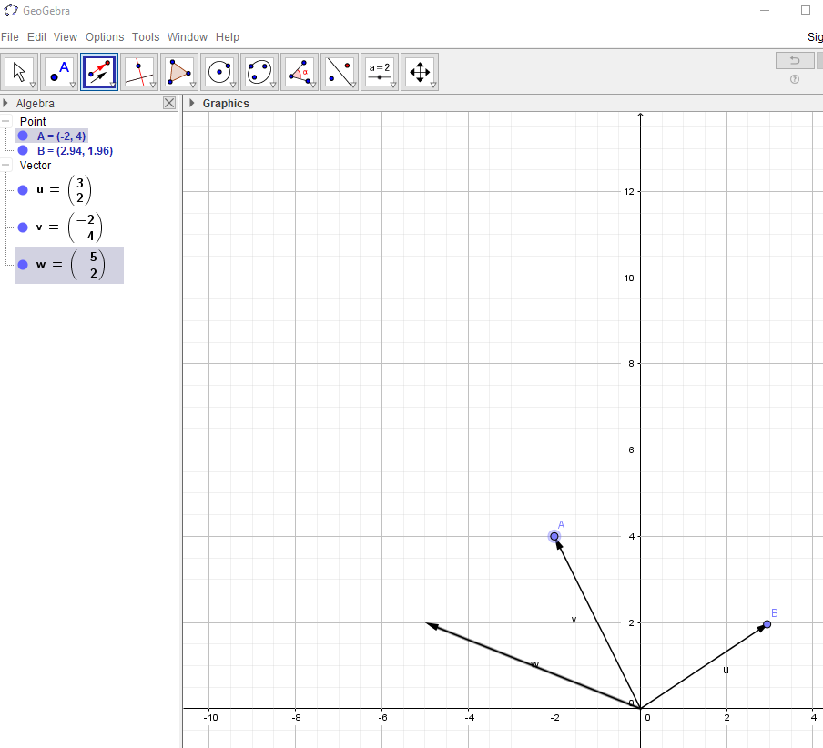
Vector W is supposed to have the same coordinates as the vector from point B to point A. To verify, click “vector from point” then click point B then vector W. v-u= ____________
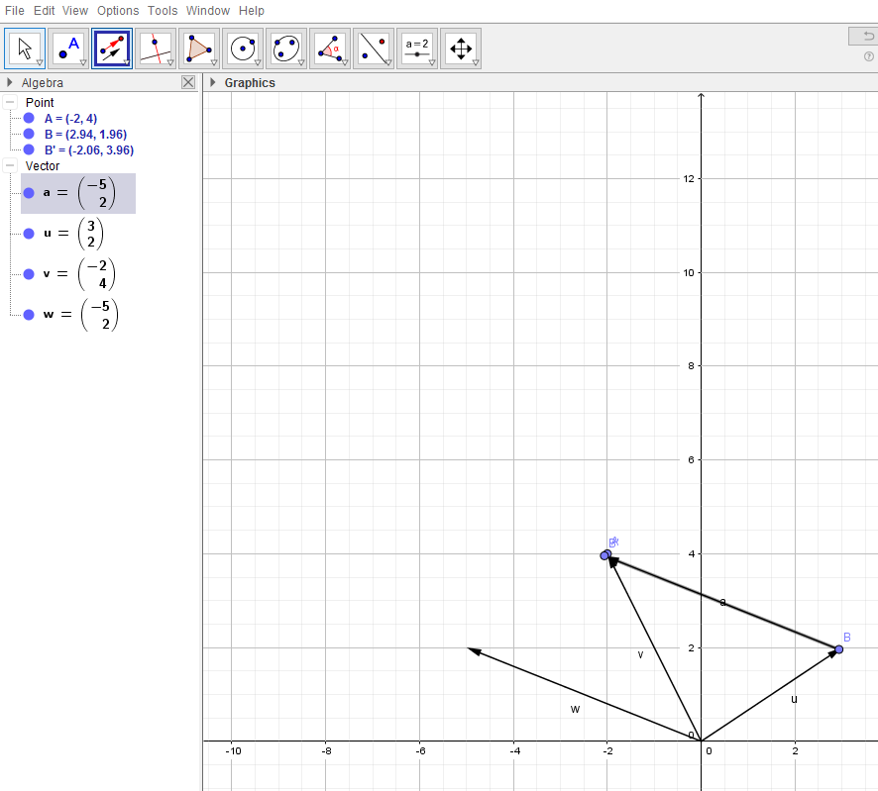

Multiplication
Type “b=3v” and “c=2u” in the “input” section. Then, you will have 3 times the length of vector v and 2 times the length of vector u.
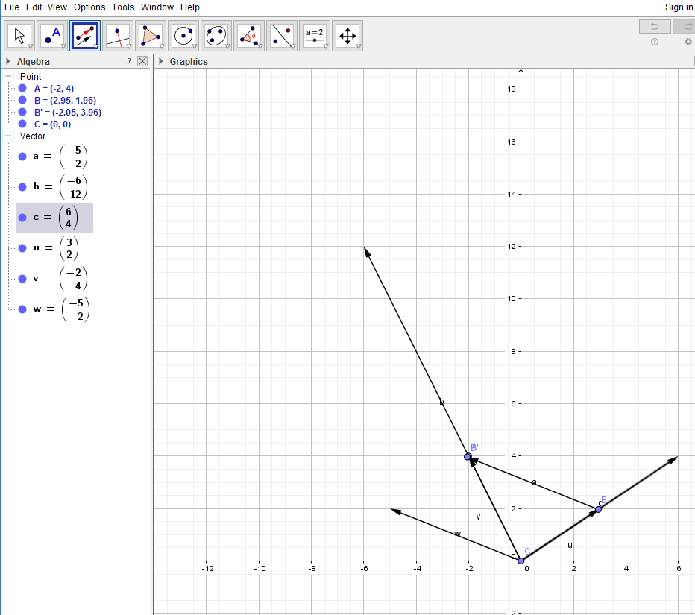
If you want to add and subtract these new vectors b and c, you can do the same process.
Practice problems:
V1=<1,1> V2=<5,-3> V3=<-3,-1> V4=<2,7>
1. V1+V3= ______________
2. 2V3-V1= _____________
3. 3V1+V2= _____________
4. V4-2V3= ______________

