Gaeun Kim
04.01.2018
MTH 4040
Hands On Activity: Pythagorean Theorem

Common Core Standards (Grade 8):
CCSS.MATH.CONTENT.8.G.B.6: Explain a proof of the Pythagorean Theorem and its converse.
CCSS.MATH.CONTENT.8.G.B.7: Apply the Pythagorean Theorem to determine unknown side lengths in right triangles in real-world and mathematical problems in two and three dimensions.
Objectives:
- Students will explain a proof of the Pythagorean Theorem.
- Students will use the Pythagorean Theorem to find side lengths of right triangles.
- Students will apply the Pythagorean Theorem to determine unknown side lengths in right triangles in real-world or mathematical problems.
Pythagorean Theorem:
When a triangle has a right angle (90°) and squares are made on each of the three sides of the right triangle, then the biggest square has the exact same area as the other two squares put together.
It is called "Pythagorean Theorem" and can be written in one short equation:
a² + b² = c²

Skittles Proof (Activity 1)
Materials:
- A bag of Skittles
- Cardboard Boxes
- Tape
- Scissors

Given a right triangle, students will follow these steps:
- Make a right triangle with a cardboard box.
- Make squares with the sides of the right triangle with cardboard boxes.
- Put skittles into the two smaller squares (Make one layer of skittles).
- Transfer all skittles from the smaller squares to the biggest one.
- Report what you have discovered.

Starburst Proof (Activity 2)
Materials:
- A right triangle
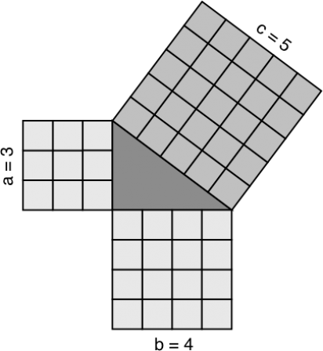
- bag of Starburst

Given a right triangle, students will follow these steps:
- Make squares with the sides of the right triangle by using starburst.
Red = a Yellow = b Orange & Pink = c
2. Move red starburst on the top of the orange and pink starburst.
3. Move yellow starburst on the top of the oranges and pink starburst.
4. Report what you have discovered.

Questions to consider:
- What is the area of each square?
- Is the square of the hypotenuse is equal to the sum of the squares of the other two sides?
- Why do you think it is useful?

Words problem:
A rectangular football field is 64 meters wide and 100 meters long. A player runs from one corner of the field in a diagonal line to the opposite corner. What is the length of a diagonal of a football field to the nearest meter?
